TEXAS
EDUCATIONAL DIAGNOSTICIANS’
ASSOCIATION
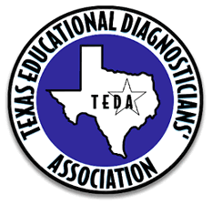

OFFICERS’
MANUAL
2019-2020
www.txeda.org

